**CO3-PYTHON LAB RECORD**

**Work with built-in packages**

1. ***PGM 1***
2. **Module math**

**INPUT**

import math

print(math.pi)

import math as m

print(m.pi)

print("===============")

from math import pi,sqrt

print(math.pi)

print(sqrt(4))

print("===============")

print("cos",math.cos(90))

print("===============")

print("sin",math.sin(90))

print("===============")

print("tan",math.tan(0))

print("===============")

**OUT PUT**

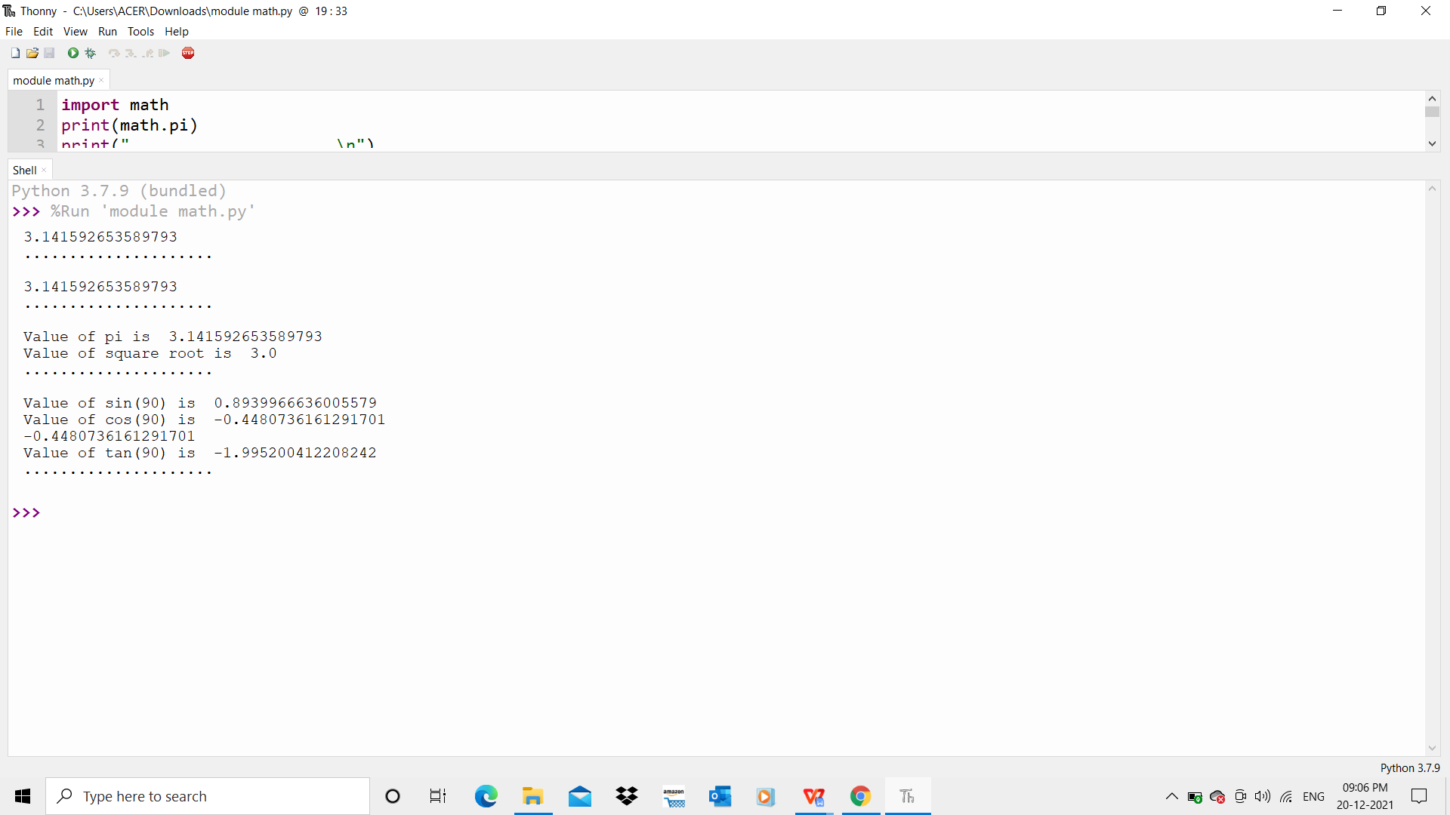

1. **Module time**

***Input:***

import time

print("current time in second",time.time())

print("===============")

print("current time",time.ctime())

print("===============")

print("current time after 30 sec:",time.ctime(time.time()+30))

print("===============")

t=time.localtime()

print("time:",t)

print("===============")

print("current month",t.tm_mon)

print("current year",t.tm_year)

print("current day",t.tm_mday)

print("current hour",t.tm_hour)

print("current miniut",t.tm_min)

print("current second",t.tm_sec)

print("===============")

**OUTPUT**

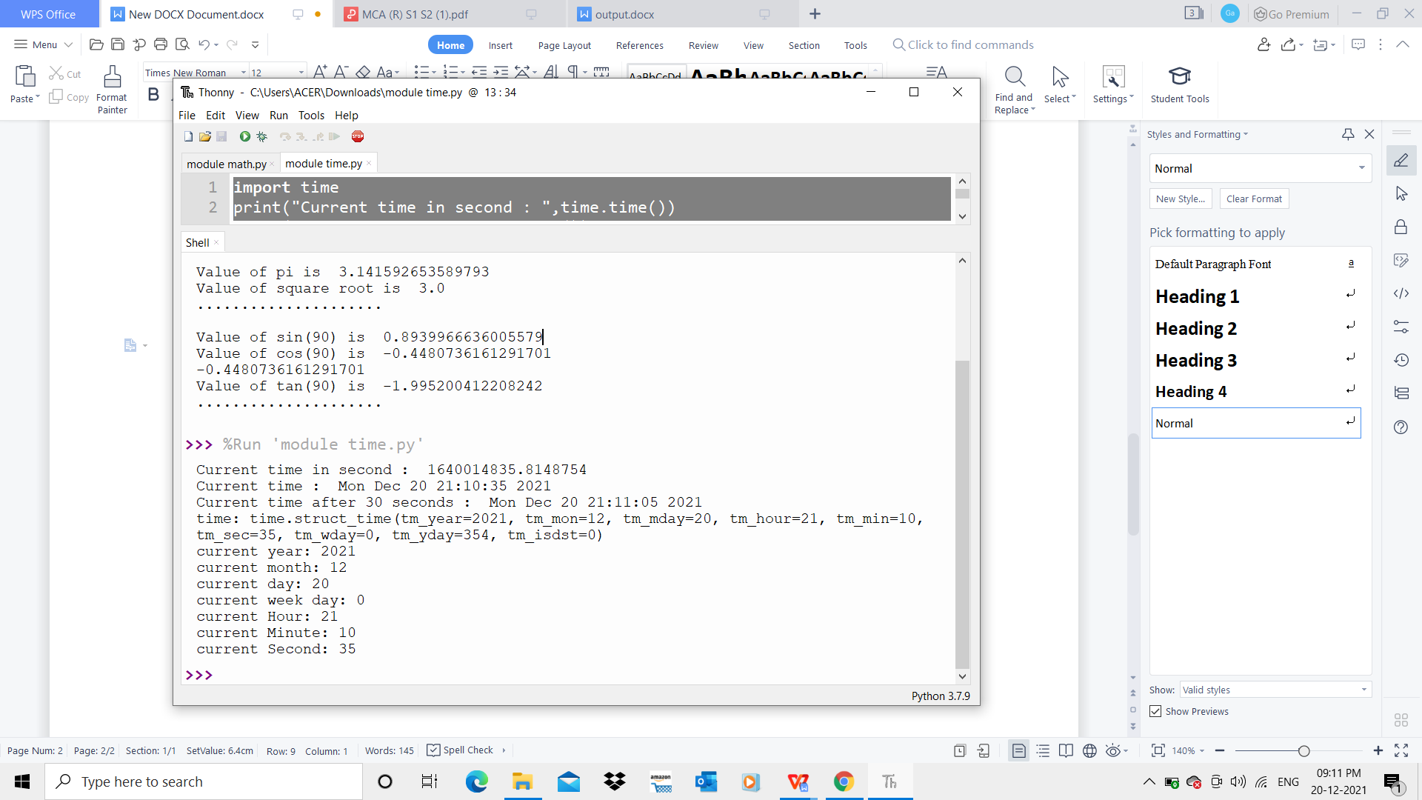

1. **Module calendar**

***Input:***

import calendar

mm=int(input("enter month:"))

yy=int(input("enter the year:"))

print(calendar.month(yy,mm))

print(calendar.calendar(2022))

print("===============")

**OUTPUT**

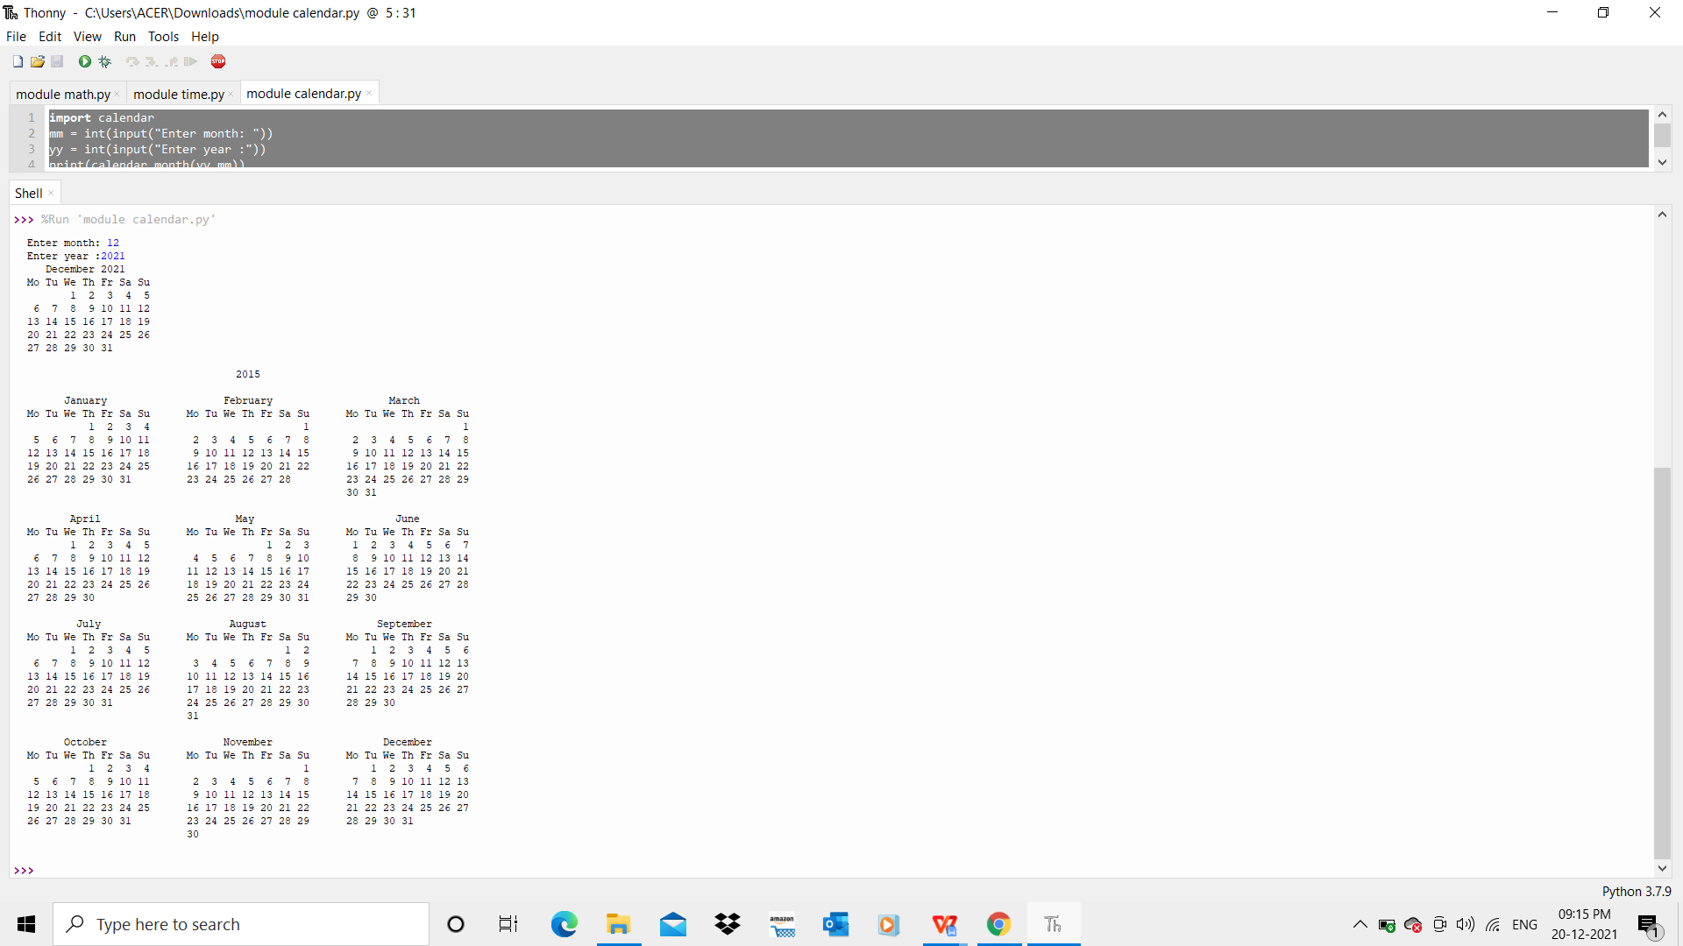

1. **Module datetime**

***Input:***

import datetime

t=datetime.time(22,56,44)

print(t)

print("hour",t.hour)

print("min",t.minute)

print("se",t.second)

print("mis",t.microsecond)

print("***********************")

d=datetime.date.today()

print(d)

print("year",d.year)

print("month",d.month)

print("day",d.day)

print(":::::")

d1=datetime.date.today()

print(d1)

td=datetime.timedelta(days=2)

print(td)

d2=d1+td

print(d2)

print("====")

dt=datetime.datetime.combine(d,t)

print(dt)

***output***

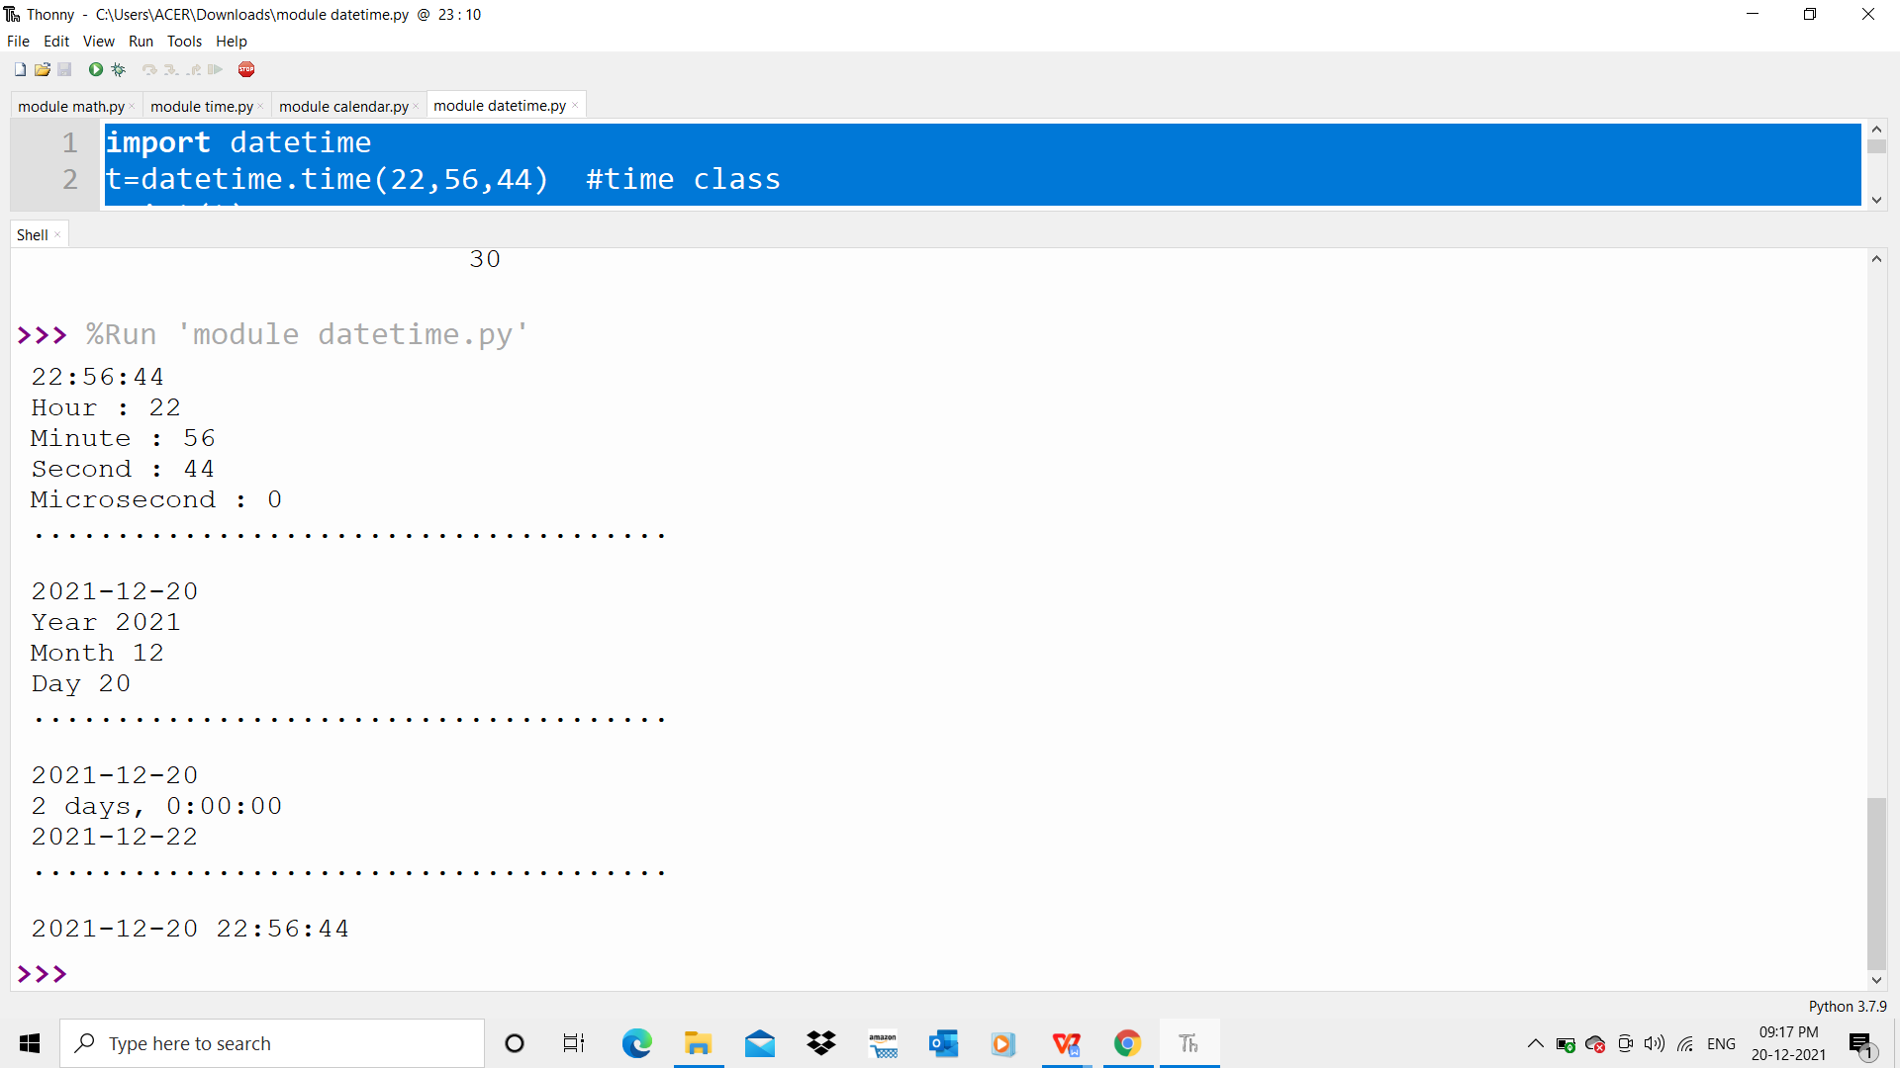

***Module Random***

**INPUT**

import random

list1 = [1, 2, 3, 4, 5, 6]

print(random.choice(list1))

print("*************")

import random

random.seed(5)

print(random.random())

print(random.random())

print("***********")

import random

r1 = random.randint(5, 15)

print("Random number between 5 and 15 is % s" % (r1))

r2 = random.randint(-10, -2)

print("Random number between -10 and -2 is % d" % (r2))

print("**************")

import random

list1 = [1, 2, 3, 4, 5, 6]

print(random.choice(list1))

string = "geeks"

print(random.choice(string))

tuple1 = (1, 2, 3, 4, 5)

print(random.choice(tuple1))

***output***

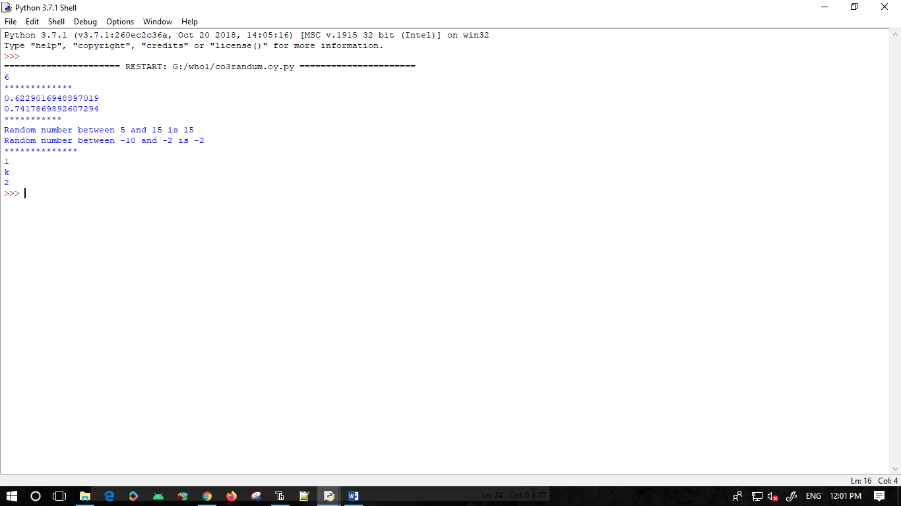

**Module Statastics**

**INPUT**

import statistics

list1 = [5,2,5,6,1,2,6,7,2,6,3,5,5]

x = statistics.mean(list1)

print(x)

y = statistics.median(list1)

print(y)

z = statistics.mode(list1)

print(z)

a = statistics.stdev(list1)

print(a)

b = statistics.variance(list1)

print(b)

***output***

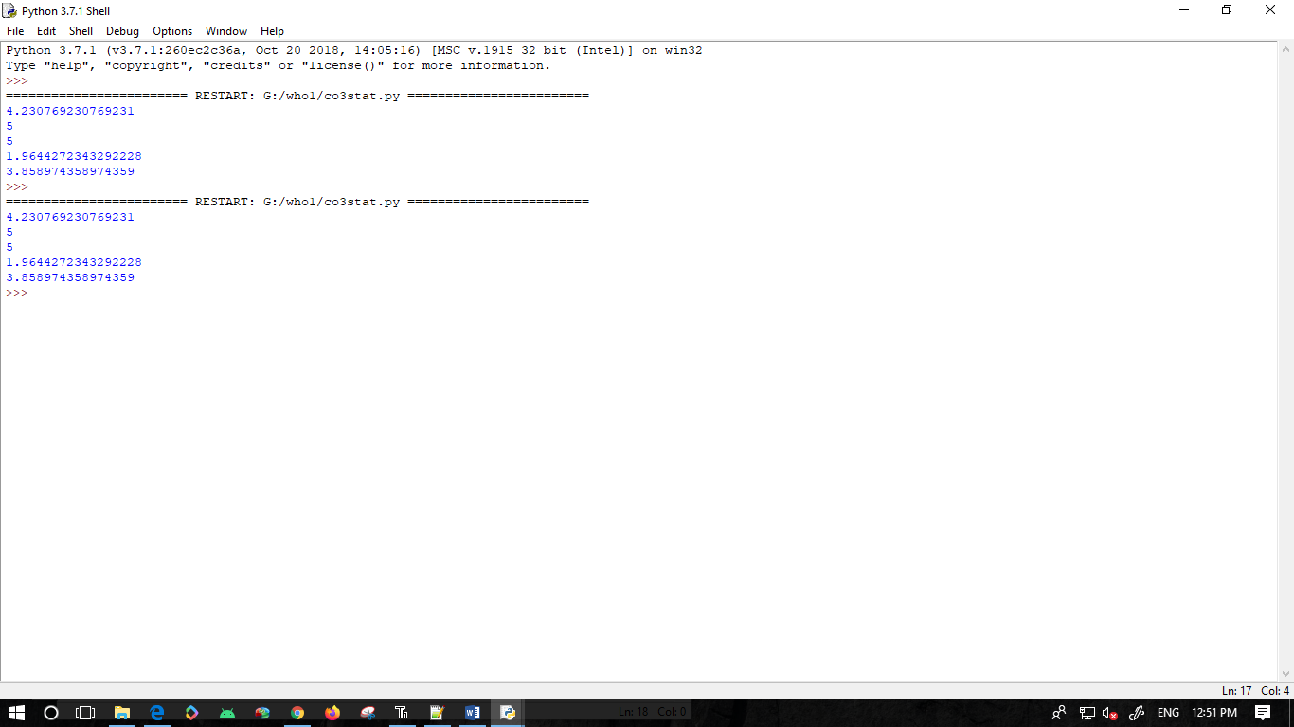

**2.Create a package graphics with modules rectangle, circle and sub-package 3D-graphics with modules cuboid and sphere. Include methods to find area and perimeter of respective figures in each module. Write programs that finds area and perimeter of figures by different importing statements. (Include selective import of modules and import * statements)**

**Solution:**

***Package graphics***

1. **__init__.py**
2. **circle.py**

***Input:***

def perimeter(r):

print ("Perimeter : ",2*3.14*r)

def area(r):

print ("Area : ",3.14*r*r)

1. **rectangle.py**

***Input:***

def perimeter(l,b):

print ("Perimeter : ",2*(l+b))

def area(l,b):

print ("Area : ",l*b)

***Subpackage ThreeDgraphics***

1. **__init__.py**
2. **cuboid.py**

***Input:***

def perimeter(l,b,h):

print ("Perimeter : ",4*(l+b+h))

def area(l,b,h):

print ("Area : ",2*l*b+2*l*h+2*h*b)

**3.sphere.py**

def volume(r):

print ("Volume : ",(4/3)*3.14*r*r*r)

def area(r):

print ("Surface Area : ",4*3.14*r*r)

***graphicsuse.py***

***Input:***

from graphics import rectangle

from graphics import circle

from graphics.ThreeDgraphics import cuboid

from graphics.ThreeDgraphics import sphere

l=int(input("Enter the length,l : "))

b=int(input("Enter the breadth,b : "))

rectangle.perimeter(l,b)

rectangle.area(l,b)

r=int(input("Enter the radius,r : "))

circle.perimeter(r)

circle.area(r)

l=int(input("Enter the length,l : "))

b=int(input("Enter the breadth,b : "))

h=int(input("Enter the height,h : "))

cuboid.perimeter(l,b,h)

cuboid.area(l,b,h)

r=int(input("Enter the radius,r : "))

sphere.volume(r)

sphere.area(r)

***Output***

